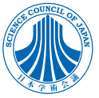
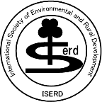
ISERD was approved to be a Cooperative Academic Research Organization
of Science Council of Japan

ISERD Secretariat in the Institute of Environmental Rehabilitation and Conservation (ERECON) is glad to inform all ISERD members that our academic society, ISERD “International Society of Environmental and Rural Development” was approved to be a “Cooperative Academic Research Organization of Science Council of Japan” on August 27, 2020.
The details of “Science Council of Japan” is in the attached file.

Executive Secretary
Machito MIHARA, Prof. Dr.

