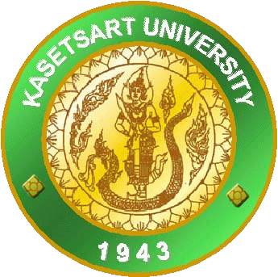





**The 10 Internationnal Conference on The 2 Nontri International Conferende**

**on Environmental and Rural Development (10 ICERD & 2 NIC)**

**Kasetsart University, Chalermphrakiat Sakon Nakhon Province Campus, Thailand.**

**February 14th -16th , 2019**

**Oral Presentation Guidelines**

1. Prepare your research presentation in MS Power Point 2007 or 2010 version.

2. Oral presenters are required to submit the soft copy of research presentation in

MS Power Point to 10th ICERD Steering Committee during the registration on Febuary 15th .

3. Respective submitted soft copies of research presentation must be installed to laptops at the

designated presentation rooms before 9:00 in the morning on Febuary 15th . Installation of soft

copies to laptops will be facilitated by the Steering Committee.

4. Each presenter will be given 10 minute presentation and 5 minutes for question and answer.

Totaling 15 minutes allocated for each presenter.

**Poster Presentation Guidelines**

1. Prepare your poster in size A0 ( 84.1cm x 118.9cm )

2. Posters must be designed in **portrait** orientation.

84.1 cm



118.9 cm

4. Poster must include Title, Authors name, Abstract and the IMRAD (Introduction, Objectives,

Methodology, Results and Discussion, Conclusion) structure of research paper.

It is highly recommended to emphasize more on the Results and Discussion section showing charts, tables, figures, and others.

5. Poster presenters are responsible for setting or fixing your poster onto the exhibit board from 7.30 to 8.30 a.m. on Feb 15th and removing from the exhibit board at 4.30 p.m. after the conference.

The Scientific Committee of the 10th ICERD will provide the Award of Excellent Paper for oral presentation and Award of Excellent Poster Presentation. Certificate of excellence will be given to awardees.

**Full manuscript** is also one of the criteria to be evaluated for the award. Prospective research presentation awardees are not entitled for the award without submitting of full manuscript.